STEPS TO RUN.

1. Open the visual studio like administrator, to avoid problems with file handling(saved csv).

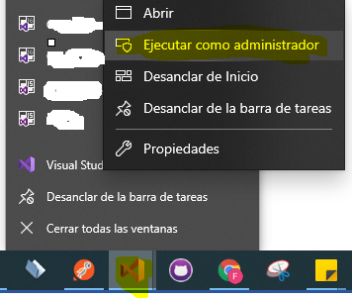

1. Start Debugging.

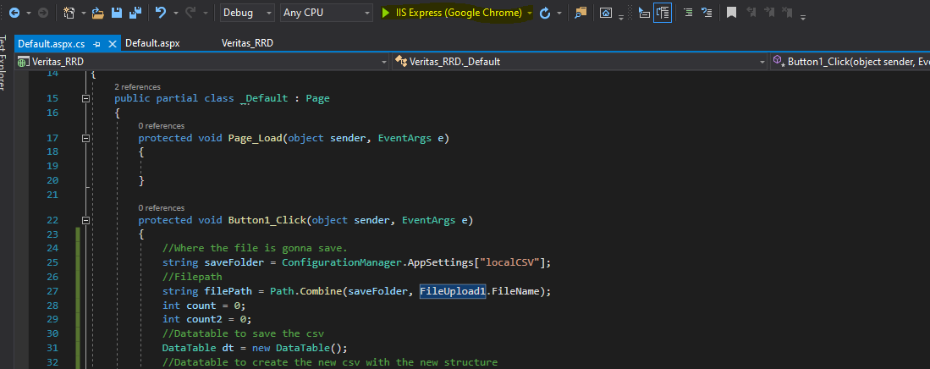

1. The application opens the default.aspx.

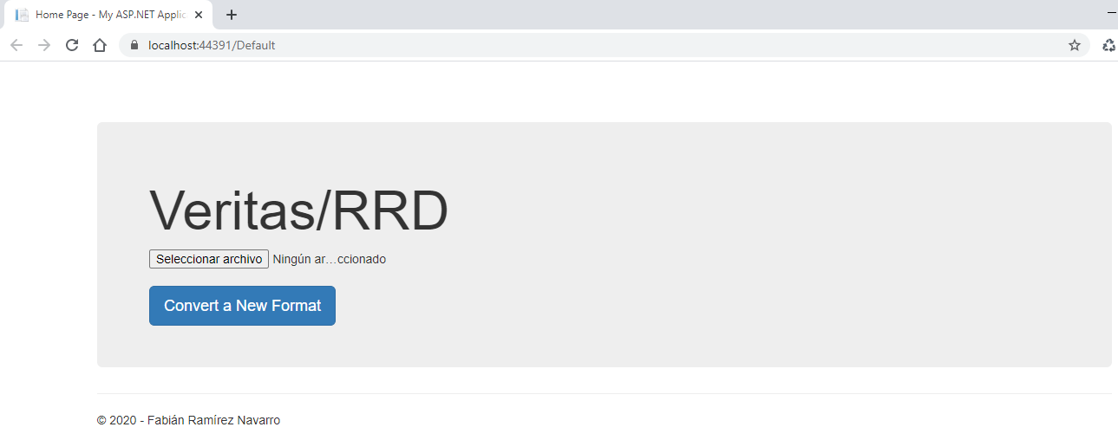

1. Click to select the Mock_Data.csv file.

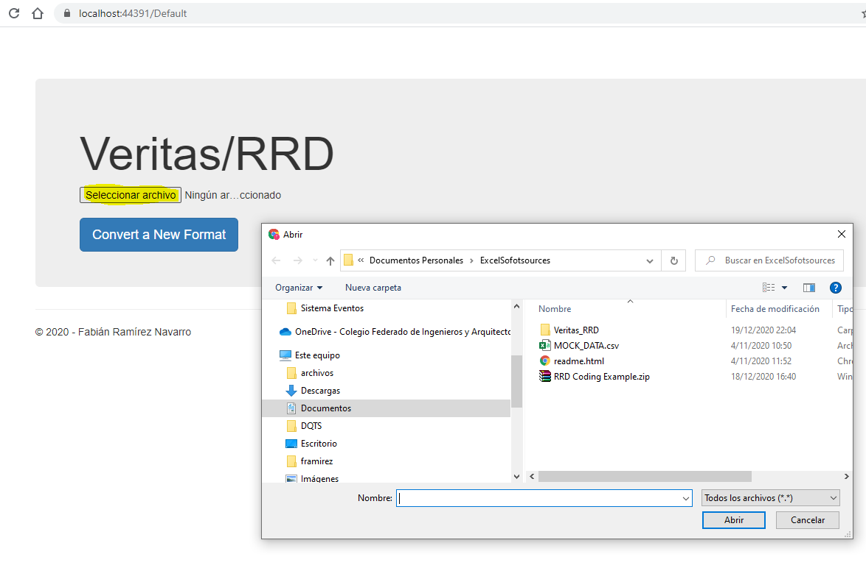

1. Click to convert a new format.

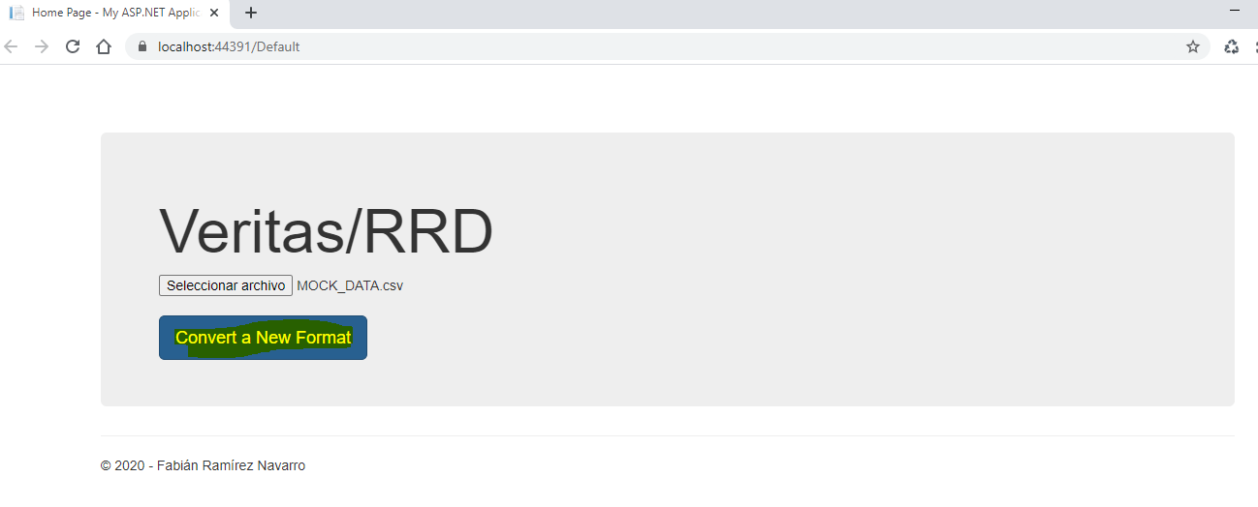

1. Find the new CSV file in C://.



Old CSV.

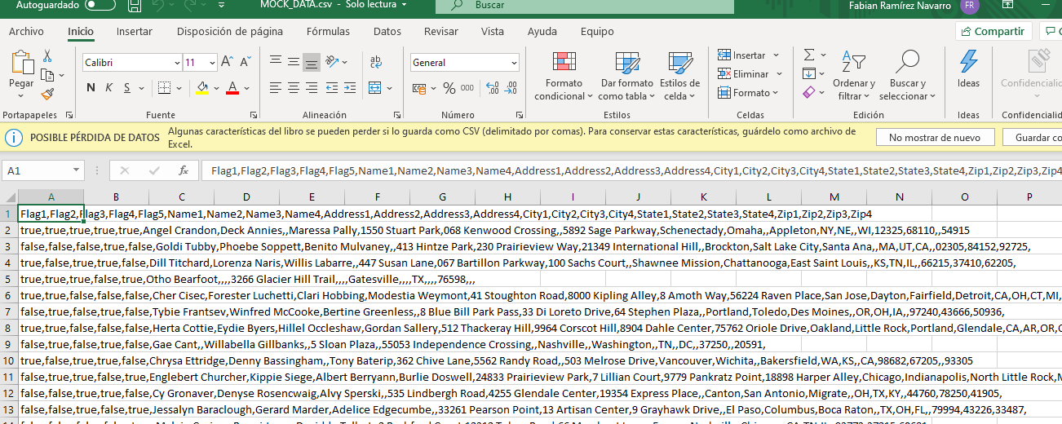

New CSV.

